SOLUTION DESIGN DOCUMENT

Advanced AI QA Testing Harness
for Visual Studio Code
Analyze | Explore | Design | Execute | Investigate | Report
PREPARED FOR  QA / Engineering Team | PROPOSED STACK  VS Code extension (TypeScript) • Python engine • GitHub Copilot SDK • Playwright • pytest | APPROACH  Human-approved, phased build with security by design

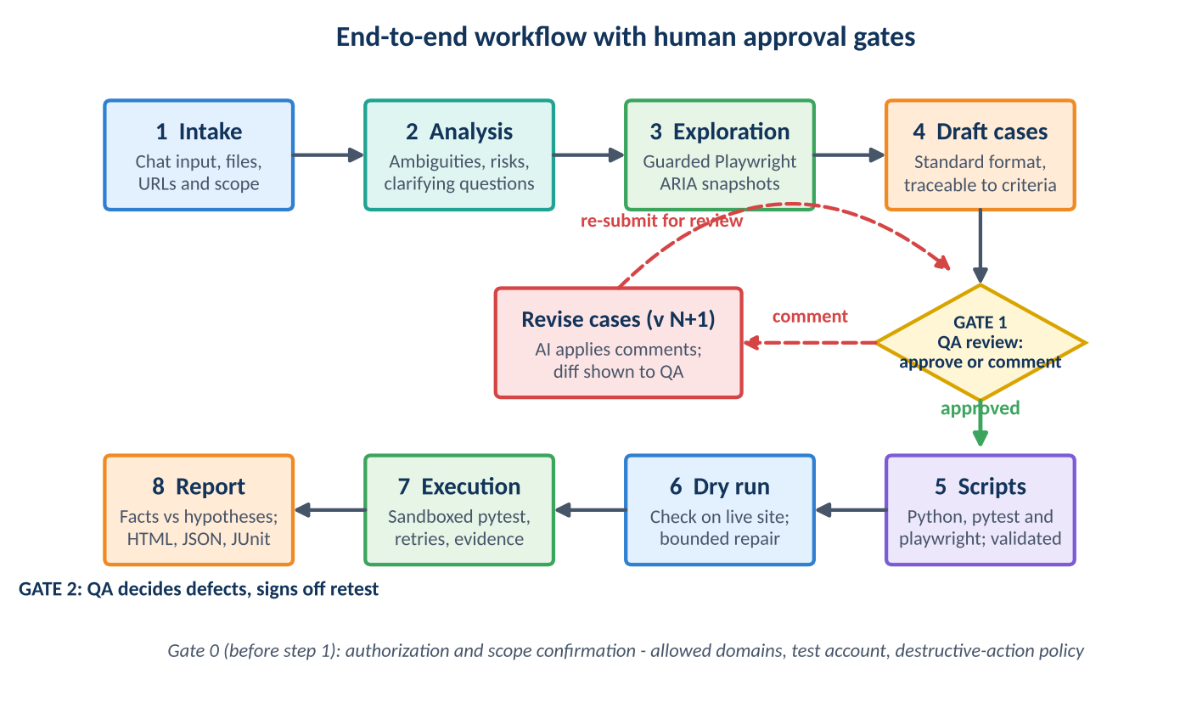
Prepared as a design and discussion document. It extends the AI-Driven QA Investigation Workflow proposal into a chat-driven, programmatic harness.
Version | Date | Status | Classification
1.0 (draft) | 7 November 2026 | For team review | Internal

1. Executive Summary
This document defines the design of an advanced QA testing harness delivered as a Visual Studio Code extension with a chat interface, in the style of modern coding-agent chat panels. A QA engineer describes the requirements and the target website in plain language. The harness analyzes them, explores the relevant pages through a controlled browser, drafts test cases in a standard format, and asks the engineer to approve them. Comments can be added to request changes, and the cycle repeats until the engineer approves. Only then does the harness write Python test scripts, run the full test process against the website, and produce a structured report.
The solution has two cooperating parts. A thin TypeScript extension provides the chat window, approval cards, settings, and secret storage. A Python QA engine, started locally by the extension, performs the orchestration, AI reasoning, browser exploration, script generation, test execution, failure investigation, and reporting. The engine uses the GitHub Copilot SDK as its reasoning layer, Playwright for Python for browser work, and pytest for execution. The two parts communicate over a local JSON-RPC channel on standard input and output, with no network listener.
Three principles shape every decision. The AI proposes and deterministic tools execute. Humans approve at the points that matter. Every piece of external content, including web pages, logs, requirement text, and generated code, is treated as untrusted until proven otherwise. Security is therefore designed in from the first phase: a threat model, deny-by-default permissions for the model, scope and network controls, redaction, script validation, sandboxed execution, a tamper-evident audit trail, and supply-chain safeguards.
A note on security assurance
No software can honestly be guaranteed to contain zero vulnerabilities. The objective of this design is that a single failure, whether a model error, a malicious web page, or a defect in one component, cannot by itself expose credentials, damage data, or cause activity outside the approved scope. Section 10 sets out the controls, and Section 12 and Appendix E set out how they are verified before release.

Key design decisions
Area | Decision | Reason
Interface | Custom chat webview in a VS Code extension | Needed for approval cards, comment boxes, live progress, and report viewing, which a plain text chat cannot provide.
Engine language | Python (3.10 or later) | Matches the team's QA stack (Playwright for Python, pytest) and the Python edition of the Copilot SDK.
Extension language | TypeScript (UI shell only) | VS Code extensions run on Node.js. The shell contains no QA logic.
AI brain | GitHub Copilot SDK (Python) behind an LLMProvider interface | Uses the team's existing Copilot access. The interface limits impact if the preview SDK changes.
Page exploration | Guarded Playwright tools returning accessibility-tree (ARIA) snapshots | Compact, semantic, and cheaper than screenshots. The model never receives raw JavaScript or shell access.
Final test run | Deterministic Python scripts run by pytest, with no LLM in the loop | Repeatable, reviewable, and CI-ready. AI is used to create and investigate, not to decide pass or fail.
Human control | Gate 0 scope, Gate 1 test-case approval, Gate 2 defect decision | Keeps responsibility for requirements, approval, and defect decisions with the QA engineer.
Security | Defense in depth with a written threat model | No single control is trusted to carry the whole risk.

2. Problem Statement
Conventional automation executes predefined checks well, but the work around it remains largely manual and uneven.
- Test preparation is repetitive, and requirement ambiguity or coverage gaps are often found late.
- Test cases are written in inconsistent formats, which makes review, traceability, and reuse difficult.
- Writing reliable scripts for a new site requires understanding its live structure, and selectors chosen without that understanding are brittle.
- A failed test rarely explains itself. The cause may be the product, the automation, the test data, the environment, or an unclear requirement, and the evidence is scattered across logs, screenshots, traces, and network responses.
- General-purpose AI assistants lack the guardrails a testing tool needs. They can act without review, process sensitive data, and follow instructions hidden in a web page.
- Teams need a repeatable, auditable, human-supervised process that works across many different websites without writing custom code for each one.

3. Objectives and Design Principles

3.1 Objectives
ID | Objective
O1 | Let a QA engineer start a complete test cycle from a chat message that contains requirements and a target website.
O2 | Analyze requirements, identify ambiguity and risk, and ask clarifying questions instead of inventing expectations.
O3 | Explore the target pages dynamically so the harness works on any authorized website without site-specific code.
O4 | Produce test cases in a single professional format, traceable to the requirements, with a review loop that supports comments and revisions.
O5 | Generate, validate, and run Python Playwright and pytest scripts only after the test cases are approved.
O6 | Investigate failures using collected evidence, separating observed facts from hypotheses.
O7 | Deliver a complete, reproducible report with full traceability from requirement to result.
O8 | Meet a high security and privacy bar throughout, with controls that are testable and auditable.

3.2 Design principles
- Human in the loop. Scope, test-case approval, and defect decisions are explicit gates. Nothing is executed on the user's behalf before the relevant gate is passed.
- AI proposes, deterministic code disposes. The model produces suggestions in validated structures. Policy code, not the model, decides what may run.
- Evidence over assertion. Every conclusion cites evidence. Facts and hypotheses are reported separately, and “insufficient evidence” is a valid result.
- Least privilege. The model has a short allowlist of read-only or tightly bounded tools. The extension requests only the permissions it needs.
- Untrusted by default. Web content, logs, requirement text, and generated code are data, never instructions.
- Dynamic by discovery, not by code. Site knowledge comes from exploration and configuration, so no per-site adapters are required.
- Reproducible and auditable. Each run stores versioned artifacts and a tamper-evident audit log.
- Fail closed. When a policy check cannot be completed, the action is refused and the user is told why.
- Provider independence. The Copilot SDK sits behind an interface, because it is currently a technical preview that may change.

4. Proposed Solution
The QA engineer remains responsible for interpreting requirements, approving tests, and deciding on defects. The harness takes over the repetitive and analytical work in between. Inside VS Code, the engineer opens the harness chat panel and works through one conversation per test run.
The harness will:
- Accept requirements, acceptance criteria, instructions, and target URLs from chat messages or workspace files.
- Analyze them to flag ambiguities, risks, assumptions, and missing information, and ask questions before proceeding.
- Visit the specified pages with a controlled browser and build a profile of the real page structure, forms, and behaviors.
- Draft test cases in a standard English format, map them to requirements, and present them for approval.
- Accept comments, revise the test cases, and ask for review again until they are approved.
- Generate Python Playwright and pytest scripts for the approved cases, validate them, and run the full test process.
- Investigate failures using the collected evidence and produce a complete report with findings, uncertainty, and next steps.
- Rerun failed and related tests after fixes.

How this differs from a general AI chat assistant
Aspect | General AI chat or agent | This harness
Execution | May run commands or code with little review. | Only validated scripts from approved test cases run, in a sandbox.
Browser access | Often broad, sometimes with arbitrary JavaScript. | Allowlisted domains, guarded tools, no raw JavaScript for the model.
Approval | Ad hoc, conversational. | Formal gates; approvals are recorded against a content hash.
Claims | Stated in prose, hard to verify. | Facts cite evidence IDs; hypotheses are labeled with confidence.
Repeatability | One-off. | Versioned artifacts and deterministic scripts that can be rerun or moved to CI.
Data handling | Unconstrained. | Scope limits, redaction, data minimization, and an audit log.

5. End-to-End Workflow
Figure 1. The workflow has three human gates. Comments at Gate 1 loop back to revision until the test cases are approved.
Stage | Description | Output and gate
0. Authorization and scope | The engineer confirms they are authorized to test the target, and sets the allowed domains, environment type, test-account reference, destructive-action policy, and limits. | scope.json  Gate 0: scope confirmed
1. Requirement intake | Requirements, acceptance criteria, business rules, instructions (for example “test only the cart page”), and URLs arrive through chat or workspace files. Secrets and personal data are redacted before any AI processing. | requirement.md  redaction-report.json
2. AI analysis and clarification | The AI identifies ambiguity, risk, missing scenarios, and regression impact. It raises questions rather than inventing requirements, and the engineer answers in chat. | analysis.json  Answered questions
3. Site exploration | Guarded Playwright tools visit the allowed pages and return ARIA snapshots. The harness builds a site profile of pages, forms, controls, and dynamic behavior. | site-profile.json  Evidence screenshots
4. Test case design | Test cases are drafted in the standard format, mapped to acceptance criteria, and summarized in a coverage matrix. | Test cases v1
5. Review loop | The engineer chooses Approve, Request changes with comments, or Reject. Each revision creates a new version with a visible diff. Approval is recorded with a content hash. | approvals.json  Gate 1: test cases approved
6. Script generation | Python Playwright and pytest scripts are generated for the approved cases and pass a static validation pipeline. An optional script review can be required. | Validated scripts
7. Dry run and stabilization | Each script runs once against the live site. Locator and timing issues are repaired within strict bounds. Changes to expected results are never applied automatically. | Repair log  Blocked cases listed
8. Full execution | Pytest runs in a sandbox across the approved browsers and viewports. Failed tests are retried to detect flakiness, and evidence is captured. | Results, traces, screenshots
9. Investigation and reporting | Failures are investigated using the evidence, and the report is generated in HTML, Markdown, JSON, and JUnit XML. | Report package
10. Review and retest | The engineer decides which failures are defects, signs off, and triggers a retest after fixes. | Gate 2: defect decisions and sign-off

6. High-Level Architecture
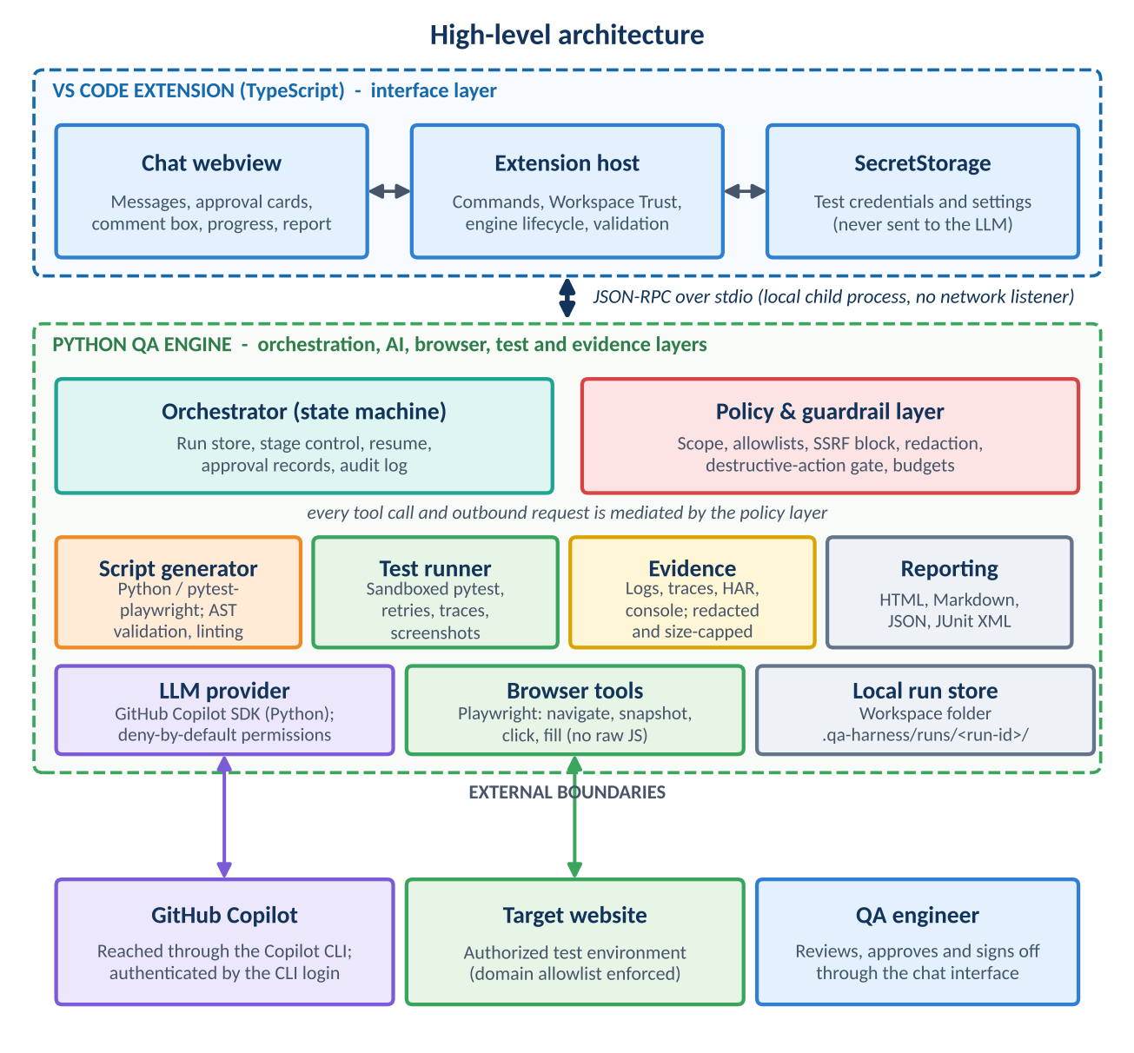
Figure 2. A TypeScript extension provides the interface. A Python engine does the work. All external boundaries are crossed through the policy layer.

6.1 Logical layers
Layer | Responsibility | Technology
Interface | Chat window, approval cards, settings, secret storage, and engine lifecycle. | VS Code Extension API, TypeScript, webview
Orchestration | State machine for the run, run store, approval records, budgets, and audit log. | Python (asyncio), Pydantic
Policy and guardrails | Scope enforcement, allowlists, SSRF controls, redaction, and destructive-action classification. Every tool call and outbound request passes through it. | Python, policy rules held as data
AI reasoning | Requirement analysis, test design, script drafting, and failure investigation. Outputs are proposals only. | GitHub Copilot SDK (Python) behind LLMProvider
Browser exploration | Guarded browsing, ARIA snapshots, and the site profile. | Playwright for Python
Test generation and execution | Script generation, validation, dry run, and sandboxed execution. | pytest, pytest-playwright, Ruff, Bandit
Evidence and investigation | Collects, redacts, and indexes artifacts, and prepares failure packages for analysis. | Playwright traces, screenshots, HAR, logs
Reporting | Human-readable and machine-readable reports. | Jinja2, pytest JUnit XML
Security and governance | Cross-cutting: threat model, secure development lifecycle, audit, supply-chain controls. | See Section 10

6.2 Why a TypeScript extension and a Python engine
VS Code extensions run on Node.js, so the interface shell must be written in TypeScript. All QA logic is written in Python, as required by the team's stack. Keeping the shell thin has security value as well. The extension holds no test logic and no model access, and the engine has no user interface.

6.3 Process model and communication
- The extension starts the engine as a child process inside a managed Python virtual environment that it creates in its own storage folder. Dependencies are installed from a lock file with hash verification.
- Communication uses JSON-RPC 2.0 over the child process's standard input and output. The engine opens no network listener, so no other local process can connect to it.
- Every message is validated against a schema on both sides. Unknown methods and malformed messages are rejected and logged.
- The engine is stateless between runs except for the run folder. A run can be resumed after VS Code restarts.
- Cancel is always available and terminates the engine's whole process tree, including browsers and test runners.

6.4 AI reasoning layer: GitHub Copilot SDK
The Python edition of the GitHub Copilot SDK is the reasoning layer. According to its public documentation, the SDK wraps the Copilot CLI over JSON-RPC and offers sessions, custom tools, streaming, hooks, MCP server integration, bring-your-own-key providers, and session persistence. It requires the Copilot CLI to be installed and a GitHub Copilot subscription unless a bring-your-own-key provider is used.
Because the SDK is in technical preview and may introduce breaking changes, the harness applies four safeguards:
- All model access goes through an internal LLMProvider interface, so the SDK can be replaced or supplemented without touching the rest of the engine.
- The SDK version is pinned, and contract tests run against it in CI before any upgrade.
- The SDK's permission-request handler is set to deny by default. The harness never uses a blanket approve-all handler, and it explicitly allows only the tools in Appendix C.
- A Phase 0 feasibility spike confirms the exact Python API behavior against the current official documentation before design details are frozen.

7. Proposed Technology Stack
Component | Proposed technology | Purpose
IDE integration | VS Code Extension API (TypeScript, Node.js) | Commands, webview, Workspace Trust, SecretStorage, engine lifecycle
Chat user interface | Webview (HTML, CSS, TypeScript) with strict Content Security Policy | Chat, approval cards, comment boxes, progress, report viewing
Engine language | Python 3.10 or later | Orchestration, AI, browser, test, and reporting logic
AI reasoning | GitHub Copilot SDK for Python and Copilot CLI | Analysis, test design, script drafting, investigation
Schemas and validation | Pydantic | Validate tool parameters, model outputs, RPC messages, and configuration
Web UI automation | Playwright for Python (Chromium, Firefox, WebKit) | Exploration and test execution
Test execution | pytest with pytest-playwright | Organize and run generated tests, capture evidence
Accessibility checks | axe-core, plus keyboard-navigation tests | Automated accessibility findings
Script validation | Python ast module, Ruff, Bandit | Reject unsafe or non-compliant generated scripts
Reports | Jinja2 (autoescape on), Markdown, JSON, JUnit XML | Human and machine-readable results
Static and supply-chain security | CodeQL or Semgrep, gitleaks, pip-audit, npm audit, CycloneDX SBOM | Find vulnerabilities, secrets, and risky dependencies
Quality of the harness itself | pytest, VS Code extension test runner, mocked LLM provider | Unit, integration, and security regression tests
Packaging | VSIX package with checksum and signed release process | Controlled distribution
Version control | Git with protected branches and code review | Track reviewed changes

8. Detailed Design

8.1 Chat interface and approval cards
The interface behaves like a conversation but renders structured cards for decisions. Each card is built from validated data, never from raw model text, and every dynamic value is escaped.
Element | Purpose
Streaming messages | Show analysis and status as the engine works, with a visible cancel button.
Scope and authorization card (Gate 0) | Shows allowed domains, environment type, test-account reference, limits, and policy. Requires explicit confirmation.
Clarification card | Presents the AI's questions with optional answer choices and free text.
Test-case review card (Gate 1) | Shows the cases in a table with per-case comment boxes, a general comment box, a version selector with diff, and the buttons Approve, Request changes, and Reject.
Script preview card | Shows generated scripts and validation results. An optional setting requires approval before execution.
Progress timeline | Shows each stage with status and a live step log.
Failure card | Shows each failure with expected versus actual, evidence links, category, and confidence.
Report card | Opens the HTML report, exports artifacts, and starts a retest.

Slash commands give quick access to common actions: /new, /scope, /plan, /run, /report, /resume, /cancel, and /settings.

Illustrative session
Step | Who | Message or action (example)
1 | QA | Test the checkout flow at https://staging.example.com. Requirements are in requirements/checkout.md. Only cover the cart and payment pages.
2 | Harness | Shows the scope card: allowed domain staging.example.com, environment “test”, destructive actions require approval. QA confirms.
3 | Harness | Reports three ambiguities and asks, for example, for the maximum quantity per item. QA answers.
4 | Harness | Explores the pages and summarizes: four pages visited, two forms found, one login wall handled with the test account.
5 | Harness | Presents 24 test cases (v1) with a coverage matrix. QA comments on one case, asking for an expired-card scenario, and chooses Request changes.
6 | Harness | Presents v2 with a diff. QA approves. The approval is recorded against the version's hash.
7 | Harness | Generates scripts, passes validation, and completes the dry run. Two locators were repaired and are listed in the log.
8 | Harness | Executes the full run with live progress, then investigates the failures.
9 | Harness | Shows the report card with the result counts. QA reviews the failures, marks defects, and signs off.

8.2 Requirement intake and scope
Inputs can be typed in chat or taken from workspace files. Each run begins with a scope definition that the engineer confirms at Gate 0.
Input | Description
Requirements and acceptance criteria | Pasted text or Markdown and text files from the workspace.
Target URL and start page | One or more URLs. Allowed domains are derived from them and shown for confirmation.
Instructions | Free-text focus such as “test only the registration form” or “skip the blog”.
Credentials reference | A name that points to a secret in VS Code SecretStorage. The model never sees the value.
Environment type | Test, staging, or other. Production is flagged with a warning and requires extra confirmation.
Execution options | Browsers, viewports, retries, and rate limits.
Limits | Maximum pages, steps, time, and model usage.
Data classification | Synthetic, sanitized, or other. This determines what may be sent to the AI service.

Example scope file (illustrative):
{
"target": {
"start_url": "https://staging.example.com",
"allowed_domains": ["staging.example.com"],
"environment": "test"
},
"credentials_ref": "secret://qa-harness/staging-user",
"policy": {
"destructive_actions": "require_approval",
"max_pages": 25, "max_steps": 150,
"respect_robots": true, "rate_limit_rps": 2
},
"execution": {
"browsers": ["chromium"],
"viewports": ["desktop", "mobile"],
"retries": 2
},
"data_classification": "synthetic"
}

At Gate 0 the engineer attests that they are authorized to test the target. The attestation, the scope, and the time are written to the audit log. Before any text goes to the AI service, a redaction step removes secrets and personal data patterns and produces a redaction report for the engineer to review.

8.3 AI analysis and clarification
The AI analyzes the requirements together with the engineer's instructions and returns a structured result that is validated before it is shown.
- Ambiguities and contradictions in the requirements, each with the exact text it refers to.
- Assumptions the AI would otherwise have to make, which become questions for the engineer.
- Risks and regression areas related to the requirement.
- Proposed scope: what appears to be in and out of scope for this run.
- Missing information, such as undefined limits, error messages, or roles.
The rule is firm: unknowns become questions, never invented requirements. The model's instructions state this explicitly, and the output schema has a dedicated field for questions so that gaps cannot be silently filled.

8.4 Site exploration

Approach
Exploration follows a snapshot, decide, act, snapshot loop. The harness reads the page as an ARIA accessibility tree, which is a compact, semantic text view built from roles, names, and states. The harness assigns a short reference to each interactive element. When the model chooses an action, the harness resolves the reference to a role-and-name locator and performs it through Playwright. This is cheaper than sending screenshots, avoids guessing at pixel coordinates, and aligns with the role-based locators used in the generated tests. Screenshots are still captured, but as evidence for humans.
Exploration is read-mostly. The tools can navigate within allowed domains, open menus and tabs, scroll, and read. Actions that change state, such as submitting forms, deleting, or purchasing, are classified and blocked unless the scope allows them or the engineer approves them on a card. The model has no JavaScript evaluation tool, no shell, and no ability to leave the allowed domains.

What the site profile contains
- Pages and URL patterns, titles, headings, landmarks, and navigation structure.
- Forms and fields, including types, labels, required markers, and visible validation rules.
- Interactive components such as menus, dialogs, tabs, tables, and date pickers.
- Authentication walls, session behavior, and cookie or consent banners.
- Presence of iframes, shadow DOM, downloads, uploads, and pop-ups.
- Console messages and failed network requests seen during exploration.

Making the harness work on any website
No site-specific code is written. The behavior adapts through discovery and configuration. The table shows how common challenges are handled.
Challenge | Approach
Single-page applications and late rendering | Wait for specific page states or network quiet using web-first waits. Fixed sleeps are not used.
Iframes and shadow DOM | Resolved through Playwright's frame handling and role-based locators, which work with open shadow roots.
Cookie and consent banners | Detected in the first snapshot. Dismissal follows a rule the engineer approves.
Login | Performed by the engine with the test account from SecretStorage. Authenticated state may be reused through a protected session file.
CAPTCHA, multi-factor authentication, bot protection | Not bypassed. The harness pauses, tells the engineer, and asks for a test environment setting or manual step.
Pop-ups, new tabs, downloads | Handled through Playwright events. Downloads go to a quarantined run folder.
File uploads | Use harmless sample files supplied by the harness or engineer.
Lazy loading and infinite scroll | Scroll under a step budget and record what was reached.
Language and locale | Detected and recorded. Test expectations are stated in the requirement language.
Canvas-heavy or purely visual interfaces | Limited ARIA information. The harness reports reduced confidence and may suggest visual checks.

8.5 Test case design
Test cases are written in English in one standard format. They are stored as validated JSON for machines and rendered as Markdown and tables for people. The same structure is used in every run so that review and traceability stay consistent.
Field | Description
Test case ID | Unique, for example TC-LOGIN-003.
Title | One short sentence stating what is verified.
Requirement reference | The requirement or acceptance criterion ID or text this case traces to.
Category | Functional positive, functional negative, boundary, UI, accessibility, responsive, cross-browser, console and network, basic performance, or passive security.
Priority | P1 to P4, with a one-line rationale for P1.
Preconditions | State and data that must exist before the steps start.
Test data | Values or placeholders such as {{TEST_USER}}. Secrets are never shown.
Steps | Numbered, one action per step, written from the user's point of view.
Expected result | Observable and specific outcomes. No implementation detail.
Postconditions and cleanup | State to restore after the test.
Automation candidate | Yes or no, with the reason if no.
Version and status | Version number, draft or approved, and approval reference.

Writing rules
- Each case verifies one behavior and has observable expected results.
- Steps contain no selectors or code, so the case stays valid if the page implementation changes.
- Every case traces to at least one requirement. Cases that cannot be traced are marked as assumptions and highlighted for the reviewer.
- Design techniques are applied and named in the plan: equivalence partitioning, boundary value analysis, decision tables, state transition, and error guessing.
- A coverage matrix lists each requirement against its cases and shows gaps explicitly.
Appendix A shows a complete example.

8.6 Review and approval loop
- The harness presents version 1 of the test cases and the coverage matrix.
- The engineer chooses Approve, Request changes, or Reject. Comments can be attached to individual cases or to the whole set. The engineer may also edit the Markdown file in the workspace, and the harness re-imports and validates it.
- On Request changes, the AI applies the comments and creates the next version with a change log. A diff is shown, and the harness asks for review again.
- On Approve, the harness records the approver, the time, the version, and a SHA-256 hash of the approved set. Only that hash may enter script generation.
- Any change to the test cases after approval invalidates the approval. The engine verifies the hash before script generation and before execution, and stops if it does not match.
- On Reject, the run returns to analysis or ends, as the engineer chooses. A configurable maximum number of revisions prevents endless loops.

8.7 Script generation and validation
Scripts are Python, written for Playwright and pytest. The generator follows a fixed structure so that output is predictable and reviewable.
- One test function per approved case, marked with @pytest.mark.tc("TC-ID") so results map back to the requirement.
- Page objects for each discovered page, with locators chosen in this order: role and name, label, visible text, and test identifiers. Brittle XPath and long CSS chains are avoided.
- Web-first assertions with automatic waiting. Fixed sleeps are not allowed.
- Independent, repeatable tests that create and clean up their own data.
- Secrets and base URLs come from harness fixtures, never from literals in the scripts.
- The steps from the approved case appear as comments, so the script can be read against the test case.
The model may write only to the tests/ and pages/ folders of the run. The fixtures, the network policy plugin, and the configuration file are owned by the harness and are read-only to generated code.

Validation pipeline
Check | What it enforces
Parse | Scripts must parse with the Python ast module.
Import allowlist | Only approved modules such as pytest, playwright, re, json, and datetime can be imported.
Banned constructs | No shell or process calls, no eval or exec, no dynamic imports, no sockets or outbound HTTP libraries, no file access outside the run data folder, and no use of ctypes or pickle.
Lint and security scan | Ruff and Bandit must pass without blocking findings.
Traceability | Every approved case has a test, and there are no tests without an approved case.
Literal check | No hard-coded secrets. Any URL literal must match the allowed domains.
Optional human review | When enabled, the engineer approves the scripts on the script preview card.

8.8 Dry run and stabilization
Each script is run once against the live site with tracing. If a test fails, the harness classifies the failure as a locator problem, a timing problem, a data problem, or a real mismatch with the expected result. Repairs are bounded.
- Only locators, waits, and data setup may be repaired, with a limited number of attempts per test.
- Assertions and expected results are never changed automatically. A mismatch goes back to the engineer, because it may be a real defect or a requirement problem.
- Every repair is logged with a diff and shown in the report.
- Tests that still fail are marked as blocked and listed, not silently dropped.

8.9 Execution
Aspect | Design
Process | Pytest runs in a separate process started with an argument list and no shell. The working directory is the run folder.
Environment | A cleaned environment passes only the variables the run needs.
Limits | Per-test and per-run timeouts, concurrency caps, and resource limits where the operating system supports them. Cancel ends the whole process tree.
Browsers and viewports | Chromium by default. Firefox, WebKit, and additional viewports are enabled by the approved plan.
Isolation | A fresh browser context for each test. No access to the engineer's own browser profile, cookies, or extensions.
Network | Every request, including redirects, is checked against the allowed domains and blocked address ranges. See Section 10.
Rate and parallelism | Conservative defaults so the target is not stressed. Parallel workers are optional and capped.
Retries and flakiness | Failed tests are retried a set number of times. A test that fails and then passes is marked flaky, not passed.
Evidence | Trace on first retry, screenshot on failure, console and network logs, and optional video.
Hardened mode | Optional execution inside a container or dev container for stronger isolation.

8.10 Extended test coverage
Beyond functional checks, the harness can add the following categories when they are in scope. They appear in the plan so the engineer can include or exclude them.
Area | Method | Notes
Functional positive, negative, boundary | Scripts built from the approved cases | Core of every run.
UI and content | Element presence, labels, states, and validation messages | Compared with the requirement text.
Accessibility | axe-core rules and keyboard navigation checks | Automated tools find only a subset of issues. The report says so.
Responsive layout | Selected viewports | Checks reachability and visibility of key controls.
Cross-browser | Chromium, Firefox, WebKit | Optional per run.
Console and network health | Capture console errors and failed requests | Reported as observations with evidence.
Basic performance | Navigation timing and page-load observations | Observation only. Not load or stress testing.
Passive security observations | Presence of security headers, cookie flags, mixed content, and visible information leaks | Observation only. No attack payloads, fuzzing, or scanning beyond scope.
Visual comparison | Baseline screenshots | Optional, because it needs maintenance.

8.11 Failure investigation
For each failure the engine assembles an evidence package: the assertion output and stack trace, the page snapshot and screenshot at failure, the trace, console and network logs, the approved test case, the related requirement, the dry-run history, and any flakiness history. The AI analyzes the package and returns a structured result.
Category | Meaning
Product defect | The application behaves differently from the approved requirement.
Automation issue | The script, locator, wait, or fixture is wrong.
Test data issue | The data was missing, stale, or conflicting.
Environment issue | The environment was unavailable or unstable.
Unclear requirement | The expected behavior is ambiguous or contradicted.
Flaky | The outcome varies between identical runs.
Insufficient evidence | The evidence does not support a conclusion.

Rules for every investigation:
- Observed facts and hypotheses are separate sections. A fact must cite the ID of a stored evidence item, and the engine rejects facts that cite items that do not exist.
- The result states a likely category, alternatives, a confidence level of low, medium, or high with its rationale, and the evidence that is missing.
- A failed test is never classified as a product defect automatically. The engineer makes that decision at Gate 2.
- “Insufficient evidence” is an acceptable result and is preferred over a guess.

8.12 Reporting
Reports are generated locally in four formats: a self-contained HTML report for reading, Markdown for version control, JSON for tools, and JUnit XML for CI systems. Content is escaped, and the HTML report carries no scripts.
Report section | Content
Executive summary | Scope, environment, date, counts of passed, failed, flaky, blocked, and skipped tests, and the overall assessment.
Requirement coverage | Matrix from each requirement to its test cases and results, with gaps shown.
Test case results | Each case with steps, expected and actual results, and status.
Failure investigations | Facts with evidence links, hypotheses, category, confidence, missing evidence, and next steps.
Flaky and blocked tests | Reasons, repair history, and recommended action.
Non-functional observations | Accessibility, console and network, performance, and passive security findings.
Run metadata | Tool and browser versions, model name, durations, and configuration.
Evidence index | Screenshots, traces, and logs with paths and IDs.
Approval history | Test-case versions, approvers, times, and hashes.
Limitations | What was not tested or could not be verified.
Recommendations | Next steps and retest plan.

9. Operating Model and Human Review
The harness is human-supervised. AI outputs are suggestions that must be checked against approved requirements and evidence.
Gate | Decision | Decided by | What it blocks
Gate 0: Scope and authorization | Allowed domains, environment, test account, policy, and limits are correct, and the engineer is authorized to test the target. | QA engineer | Any browsing or AI processing of site content.
Clarification | Answers to the AI's questions about ambiguous requirements. | QA engineer | Test design.
Gate 1: Test-case approval | The test cases are correct, complete enough, and traceable. | QA engineer | Script generation and execution.
Optional script review | The generated scripts match the approved cases. | QA engineer | Execution, when enabled.
Destructive-action approval | A specific state-changing action may be performed on the test environment. | QA engineer | That single action.
Gate 2: Defect decision and sign-off | Which failures are product defects, and whether the retest passes. | QA engineer with engineering | Closing the run.

- Ambiguous requirements are reviewed by the engineer before expectations are finalized.
- Test cases are approved before any automation is generated or run.
- AI root-cause output distinguishes observed facts from hypotheses.
- A failed test is not automatically classified as a product defect.
- The engineer can pause or cancel a run at any time.
- Final defect decisions and retest sign-off stay with the responsible team.

10. Security Architecture and Governance

10.1 Security objectives
- Confidentiality: credentials, test data, and site content are not exposed to unintended parties, logs, or reports.
- Integrity: the plan that was approved is the plan that runs, and reports reflect what actually happened.
- Availability and safety: the harness cannot harm the engineer's machine, and it cannot overload or damage the target.
- Accountability: every significant decision and action can be traced to a person, a time, and an artifact.
- Bounded autonomy: the model can propose, but it cannot act outside what policy and humans allow.

10.2 Trust zones
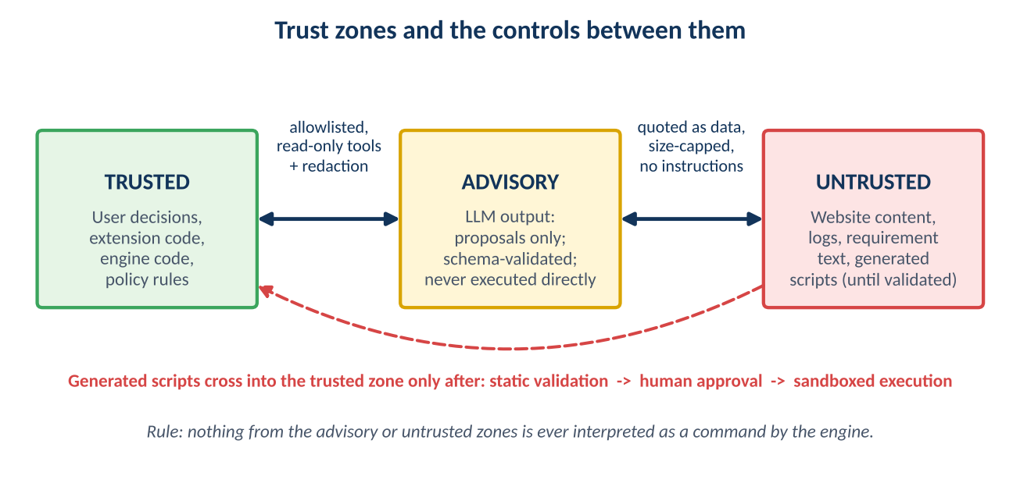
Figure 3. The model's output and all external content are never executed or obeyed directly.
The engine treats user decisions, its own code, and its policy rules as trusted. Model output is advisory and is accepted only after schema validation. Website content, logs, requirement text, and generated scripts are untrusted. Content from the untrusted zone is passed to the model as quoted data with a size cap, and instructions found inside it are ignored and flagged to the engineer. Generated scripts become eligible to run only after static validation, human approval, and execution inside the sandbox.

10.3 Threat model
The table lists the principal threats considered. The full threat model is a living document in the repository, reviewed at the end of every phase.
ID | Threat | Example scenario | Primary controls
T1 | Prompt injection through web pages, logs, or requirements | A page contains text telling the AI to ignore its rules, visit another site, or reveal secrets. | - Untrusted text passed as quoted data only  - No model tool can exfiltrate data or leave the allowed domains  - Policy layer enforces scope regardless of model output  - Schema-validated outputs  - Instruction-like content flagged to the engineer
T2 | Malicious or unsafe generated script | A generated test runs a shell command, reads a private file, or contacts an external host. | - AST import allowlist and banned constructs  - Ruff and Bandit scans  - Harness-owned fixtures that generated code cannot modify  - Sandboxed execution with cleaned environment  - Network policy at runtime  - Optional human script review
T3 | Command or argument injection | A URL or file name from the model or user is inserted into a command line. | - No shell is used anywhere  - Argument lists only  - Strict validation of every value  - No model-controlled command names
T4 | Path traversal and arbitrary file access | A tool call asks to read ../../.env or follows a symlink. | - File tools limited to the run folder and files the user selects  - Canonical path checks and symlink rejection  - No general file read or write tool for the model
T5 | Server-side request forgery and internal network access | A redirect or link leads to localhost, a private address, or a cloud metadata address. | - Domain allowlist checked on every request and redirect  - Private, loopback, link-local, and metadata ranges blocked  - Explicit opt-in for internal test environments  - Optional local policy proxy that enforces limits at connection time, which also mitigates DNS rebinding
T6 | Credential leakage | A password appears in a prompt, a log, a trace, or a report. | - Secrets only in VS Code SecretStorage  - Model sees placeholders, and the engine fills real values  - Redaction of prompts, logs, traces, HAR files, and reports  - Protected session files, excluded from Git
T7 | Sensitive data sent to the AI service | Page snapshots from a production-like site contain personal data. | - Required data-classification declaration  - Redaction before every model call  - Data minimization and snapshot truncation  - Only the approved AI service  - Per-run record of what was sent
T8 | Excessive agency and destructive actions | The agent clicks Delete account or Pay now. | - Action classification with block or approval  - Read-mostly exploration  - Test environments only by default  - Step and rate budgets
T9 | Testing a system without authorization | A user points the harness at a third-party site. | - Gate 0 authorization attestation, logged  - Strict domain scope  - Warnings for production-like targets  - Rate limits and robots.txt respected by default
T10 | Tampering with the plan after approval | Test cases or scripts change after the engineer approved them. | - Approval bound to a SHA-256 hash  - Hash verified before generation and before execution  - Mismatch stops the run
T11 | Webview script injection | Malicious page text is rendered in the chat as active content. | - Strict Content Security Policy with nonces  - No inline script and no remote content  - All dynamic content escaped  - Restricted resource roots  - Schema validation of every message
T12 | Untrusted workspace | A cloned repository contains a crafted configuration that triggers actions. | - VS Code Workspace Trust respected  - Execution features disabled in untrusted workspaces  - Configuration validated and never executed as commands
T13 | Supply-chain compromise | A malicious package version enters the build. | - Pinned versions and lock files with hashes  - pip-audit, npm audit, and SBOM  - Minimal dependencies  - Cooling-off period before adopting new releases  - Signed release artifacts
T14 | Report injection | Page content with markup appears in the HTML report. | - Autoescaped templates  - No scripts in reports  - Restrictive CSP in the report file
T15 | Denial of service to the target or host | A runaway loop or too much parallelism overloads a site or the laptop. | - Budgets for steps, pages, time, and tokens  - Rate limits and concurrency caps  - Timeouts and a kill switch
T16 | Model errors presented as facts | The AI invents a requirement or a root cause. | - Questions instead of assumptions  - Evidence ID verification  - Separate facts and hypotheses  - Human gates
T17 | Breaking changes in the preview SDK | An SDK update changes behavior or permissions. | - LLMProvider interface  - Version pinning and contract tests  - Alternative provider path
T18 | Hijack of the engine channel | Another local process tries to talk to the engine. | - Standard input and output only, with no sockets  - Engine is a child of the extension  - Message validation
T19 | Leakage through logs or telemetry | Verbose logs contain secrets or page data. | - Structured logs with redaction  - No third-party telemetry by default  - Retention and purge commands

10.4 Security control catalogue

LLM and prompt safety
- The Copilot SDK permission handler denies by default. A blanket approve-all handler is never used.
- Only the tools listed in Appendix C are exposed. There is no shell, general file access, arbitrary HTTP, or JavaScript evaluation tool.
- The system instructions require the model to ask questions, avoid inventing requirements, and treat page content as data.
- Model outputs use structured schemas validated with Pydantic, with a small bounded number of retries.
- Hooks record every tool call with redacted arguments, and block calls that violate policy.
- Context size, output size, and model usage are capped. The model name and version are logged for each run.

Browser and network safety
- A fresh, isolated browser profile is used for each run. The engineer's own browser, sessions, and extensions are never attached.
- Browser-context routing checks every request, including redirects, against the domain allowlist and blocked address ranges.
- Browser permissions such as camera, location, and notifications are not granted.
- Downloads are stored in a quarantine folder inside the run and are never opened or executed.
- Credentials are entered by the engine, not by the model.
- An optional local policy proxy provides connection-time enforcement for high-assurance environments.

Execution sandbox
- Scripts run as the current user without elevation, in a separate process, with a cleaned environment and a restricted working directory.
- Timeouts, concurrency caps, and resource limits apply. Cancel terminates the whole process tree.
- Hardened mode runs the test process in a container for stronger isolation. It is recommended for any target that is not a controlled test environment.

Secrets and data protection
- Secrets live in VS Code SecretStorage, never in settings files, prompts, reports, or Git.
- A redaction pipeline combines patterns, entropy checks, and exact matches of configured secrets. It runs on prompts, logs, traces, network captures, and reports.
- The run folder is excluded from Git by default and can be purged with a command. A retention setting is available.
- Data minimization: only the parts of a page needed for the current step go to the model.
- The team confirms with its security and privacy owners that its GitHub Copilot terms and settings permit this use before any real project data is processed.

Extension security
- Workspace Trust is respected, and execution features are disabled in untrusted workspaces.
- The webview uses a strict Content Security Policy with nonces, restricted local resource roots, and no remote content.
- No eval or dynamic code loading. All assets are bundled.
- Messages between the webview, the extension, and the engine are validated against schemas.
- Browser binaries are installed only through an explicit, user-approved step from the official source.

Supply chain and release
- Python dependencies are installed from a hash-pinned lock file. Node dependencies are installed from a lock file with integrity checks.
- Dependencies are kept minimal, reviewed when added, and audited continuously. A CycloneDX SBOM is produced for each release.
- New dependency versions are adopted only after a defined waiting period and a review.
- Releases are built in CI from protected branches after code review, with checksums and a signed release process.

Audit and accountability
- An append-only audit.jsonl file records the scope, authorization attestation, approvals, every tool call with redacted arguments, every outbound domain, script validation results, execution commands, and results.
- Each entry includes the hash of the previous entry, so tampering is detectable.
- Entries include the VS Code user, the operating system user, the time, and the model used.
- The audit log can be viewed from inside the extension and is included in the report package.

10.5 Secure development lifecycle
Activity | Detail
Threat modeling | Version 1 in Phase 0. Reviewed at the end of every phase and before release.
Static analysis | CodeQL or Semgrep, Bandit for Python, and ESLint security rules for TypeScript, on every pull request.
Secret scanning | gitleaks in pre-commit and CI.
Dependency scanning | pip-audit and npm audit in CI, with an alert on new advisories.
Security regression tests | A permanent suite covering a prompt-injection corpus, path traversal, SSRF redirects, malicious script samples that must be rejected, and script-tag payloads in page titles that must render inert.
Fuzzing | Fuzz the RPC message parser and the script validator.
Review | Mandatory code review. Security-sensitive modules require a second reviewer.
External assessment | Independent penetration test of the extension and engine before wide rollout.
Vulnerability response | A documented process for triage, fix, release, and communication of security issues.

10.6 Residual risks
Residual risk | Why it remains | Handling
The AI can still give a wrong analysis. | Language models are fallible. | Human gates, evidence citation, and confidence labels.
The preview SDK may change behavior. | It is a technical preview. | Provider interface, pinned version, contract tests.
Same-host sandbox is weaker than a virtual machine. | Default mode runs on the engineer's machine. | Hardened container mode for non-controlled targets.
Automated accessibility and security checks are partial. | Tools detect only a subset of issues. | Reports state this limitation clearly.
A compromised operating system or user account is out of scope. | The harness relies on the host's integrity. | Standard endpoint security practices apply.

Assurance statement
The design aims for layered, independently verifiable controls so that no single failure compromises the system. It does not claim that the software is free of vulnerabilities. Continuous testing, review, and a response process are part of the design for that reason.

11. Project Structure and Run Artifacts

11.1 Repository layout
qa-harness/
extension/ TypeScript VS Code extension (interface only)
src/ extension.ts, engineClient.ts, chatProvider.ts,
rpc/, security/
webview/ chat UI and cards
package.json
engine/ Python QA engine
pyproject.toml, requirements.lock (with hashes)
qa_engine/
main.py JSON-RPC server (stdio)
orchestrator/ state machine, run store, audit log
llm/ provider.py, copilot_provider.py, prompts/, schemas/
browser/ tools.py, snapshot.py, policy.py
generation/ testcases.py, scriptgen.py, validator.py
execution/ runner.py, sandbox.py, policy_plugin.py
investigation/ classifier.py, evidence.py
reporting/ templates/, builder.py
security/ redaction.py, ssrf.py, paths.py, secrets.py
tests/ unit/, integration/, security/
docs/ threat-model.md, runbooks/
.github/workflows/ CI: build, test, scan, SBOM, release

11.2 Run folder
Each run writes to its own folder in the workspace. The folder is excluded from Git by default because it can contain evidence from the target site.
.qa-harness/
config.json
runs/<run-id>/
scope.json confirmed scope and authorization record
requirement.md normalized requirement text
redaction-report.json
analysis.json ambiguities, risks, questions, answers
site-profile.json pages, forms, components
testcases/ v1.json, v1.md, v2.json, v2.md ...
approvals.json approver, time, version, SHA-256
scripts/ tests/, pages/, data/
results/ junit.xml, results.json
evidence/ screenshots/, traces/, har/, logs/
report/ report.html, report.md, report.json
audit.jsonl hash-chained audit log

12. Implementation Roadmap
Phases are sequenced by dependency and risk. Effort and calendar estimates should be set by the team after the Phase 0 spike, when the SDK behavior is confirmed.
Phase | Activities | Deliverable | Exit criteria
Phase 0: Foundation and threat model | Create repositories and CI. Add static analysis, secret scanning, and dependency audit. Write threat model v1. Run a Copilot SDK feasibility spike for sessions, custom tools, permission handling, and structured output in Python. | Project skeleton, threat model v1, spike report | Spike decisions recorded. CI gates in place.
Phase 1: Engine core | RPC server, run store, state machine, audit log with hash chain, LLMProvider and Copilot provider, schemas, policy layer basics. | Engine that runs headless with a mocked or real provider | Contract and unit tests pass.
Phase 2: Chat interface | Extension shell, webview, cards, engine lifecycle, Workspace Trust, SecretStorage, CSP and message validation. | Working chat shell connected to the engine | Webview security review passed.
Phase 3: Analysis and exploration | Intake, redaction, AI analysis and clarification, guarded browser tools, SSRF and scope controls, site profile. | Site profiles for sample sites | Injection and SSRF tests pass.
Phase 4: Test design and review loop | Standard format, coverage matrix, comments, revisions with diff, approval with hash. | Approved test-case sets | Full traceability. Hash verification works.
Phase 5: Scripts and execution | Script generator, validator, dry run, sandboxed runner, retries, evidence capture. | Validated scripts and run results | Malicious-script corpus rejected. Repeat runs stable.
Phase 6: Investigation and reporting | Evidence packages, classifier with evidence checks, report builder in four formats. | Complete reports | Accuracy measured on seeded failures.
Phase 7: Hardening and evaluation | Penetration test, fuzzing, performance tuning, pilot on three to five representative sites, baseline comparison. | Release candidate and findings | Success criteria met. No open critical or high findings.
Phase 8: Packaging and rollout | Signed VSIX, installation guide, runbooks, support and feedback process. | Released extension | Approved by security and QA leads.

13. Success Criteria and Evaluation
The harness is evaluated on a small, repeatable set of requirements, sites, and known outcomes, including sites with deliberately seeded defects. A baseline of current manual effort is recorded before any efficiency claim is made. Targets below are proposals to be agreed before implementation.
Criterion | Measure | Proposed target
Analysis quality | Reviewers rate the ambiguities and risks as relevant. | At least 80% rated relevant
Traceability | Every approved case maps to a requirement, and every generated test maps to an approved case. | 100%
Test-case quality | Reviewers accept cases without major rewrite. | At least 80% accepted by version 2
Script validity | Generated scripts pass the validation pipeline before execution. | 100% of executed scripts
Stability | Same outcomes across three repeat runs on stable demo sites. | At least 95% consistent
Investigation accuracy | Correct category on seeded failures, including correct use of insufficient evidence. | At least 80%
Evidence integrity | Facts in reports cite existing evidence items. | 100%
Security | Security regression suite passes, and the penetration test has no open critical or high findings. | All pass at release
Usability | A QA engineer completes a full cycle without leaving VS Code. | Confirmed in pilot
Efficiency | Preparation and investigation time compared with the recorded baseline. | Reported, not assumed
Privacy and access | Data classification, redaction, and approved-service requirements are met. | No violations in pilot

14. Risks and Mitigations
Risk | Potential impact | Mitigation
Incorrect generated expectations | Tests assert behavior that was never specified. | Trace tests to approved criteria, flag ambiguity, ask questions, and require Gate 1 approval.
Incorrect failure classification | A real defect is missed or an automation issue is reported as a defect. | Require evidence, alternatives, confidence, and human review.
Incomplete evidence | Root-cause conclusions are unreliable. | Report missing evidence and recommend additional checks.
Sensitive data exposure | Policy or privacy violation. | Synthetic or sanitized data, redaction, data classification, and an approved AI service.
Prompt injection from websites | The agent is steered to unsafe actions. | Untrusted-content handling, minimal tools, scope enforcement outside the model.
Unstable automation | Flaky tests reduce trust. | Role-based locators, web-first waits, retries that label flakiness, and environment checks.
Preview SDK changes | Breaking changes delay delivery. | Provider interface, version pinning, contract tests.
Sites that resist automation | CAPTCHA or bot protection blocks exploration. | Human hand-off and test-environment settings. No bypass.
Expectation that it works on every site | Disappointment with complex canvas or heavily visual applications. | State limits clearly, report reduced confidence, and offer alternative checks.
Model cost and latency | Slow or expensive runs. | Snapshot truncation, caching, budgets, and model selection per task.
Overstated AI capability | Stakeholders expect fully autonomous decisions. | Position the product as AI-assisted with human gates, and measure outcomes.
Unavailable test environment | Runs fail for reasons unrelated to the product. | Health check before execution and an environment-issue category.

15. Expected Benefits
- Less repetitive effort in requirement analysis, test design, and script writing.
- Earlier visibility of requirement ambiguity and coverage gaps.
- Consistent, traceable test cases in one professional format.
- Scripts grounded in the real page structure, with more resilient locators.
- A structured, evidence-based approach to investigating failures.
- Complete, reproducible reports that QA and engineering can review quickly.
- A tool that works across many websites without per-site development.
- Strong governance: approvals, scope control, and an audit trail.

16. Scope and Limitations
In scope | Out of scope initially
Chat-driven requirement intake in VS Code | Unreviewed autonomous decisions
AI analysis, clarification, and test-case design with a review loop | Testing any system without authorization
Guarded exploration of authorized websites | Production access or processing of sensitive data
Python Playwright and pytest script generation and execution | Load, stress, and penetration testing
Functional, UI, accessibility, responsive, cross-browser, and console checks | Native mobile and desktop applications
Failure investigation and reporting in four formats | Automatic defect creation in external trackers
Local storage of run artifacts | CAPTCHA or multi-factor authentication bypass
Synthetic or sanitized data in authorized test environments | Backend-only API testing and multi-user server deployment

17. Assumptions and Dependencies
- Each user has a GitHub Copilot subscription, and the Copilot CLI is installed and authenticated. A bring-your-own-key provider is an alternative if the organization approves it.
- The organization's security and privacy owners approve the use of the Copilot service for this purpose.
- Network access to the Copilot service and to the authorized test environments is available.
- Python 3.10 or later is available. Playwright browsers can be installed from the official source.
- An authorized test environment with synthetic or sanitized data exists.
- The Copilot SDK is a technical preview. The exact Python API and behavior are confirmed in Phase 0 against the current official documentation.
- The minimum supported VS Code version is decided in Phase 0.

18. Conclusion and Recommendation
A chat-driven QA harness built as a VS Code extension with a Python engine can take a QA engineer from a requirement and a URL to an approved test plan, executed tests, and an evidence-based report, with the engineer in control at every decision point. The architecture deliberately separates AI reasoning from execution, treats all external content as untrusted, and builds security into each layer.
It is recommended that the team begin with Phase 0, which produces the threat model and confirms the Copilot SDK behavior, and then proceed through the phases with security gates and agreed success criteria at each step.

Decision Requested
Approve the phased build of the harness, starting with Phase 0 (threat model and SDK feasibility spike), with success criteria and security release gates agreed before implementation.

Appendix A: Example Test Case in the Standard Format
Field | Example content
Test case ID | TC-LOGIN-003
Title | Login is rejected when the password is incorrect
Requirement reference | AC-2: A user who enters invalid credentials must not be signed in and must see an error message. (Illustrative.)
Category | Functional, negative
Priority | P1. Authentication failure handling is security relevant.
Preconditions | - A registered test user exists  - The user is signed out  - The Login page is reachable
Test data | - Username: {{TEST_USER}}  - Password: a synthetic incorrect value
Steps | 1. Open the Login page.  2. Enter the valid username.  3. Enter the incorrect password.  4. Select Sign in.
Expected result | - An error message states that the credentials are invalid.  - The user remains on the Login page.  - No signed-in state is created.  - The password value is not displayed.
Postconditions | None. No data is created.
Automation candidate | Yes
Version and status | v2, approved. Approval reference APR-0002.

Note: the example is illustrative. Real cases are written from the approved requirement and the observed page behavior.

Appendix B: Example Investigation Report
Field | Example content
Failed test | test_tc_login_001 (TC-LOGIN-001)
Expected result | A welcome message is displayed after a valid login.
Actual result | The welcome message was not found within the timeout.
Observed facts | - F1: The assertion timed out after 5 seconds waiting for the welcome text. (EV-014)  - F2: The screenshot shows the Login form with an error banner. (EV-015)  - F3: The network log shows the sign-in request returned a server error status. (EV-016)
Hypotheses | - H1: The authentication service was unavailable (environment issue). Supported by F2 and F3.  - H2: The locator or wait is wrong (automation issue). Less likely, because the page rendered and the error banner was found.  - H3: The test account is locked (data issue). Not excluded.
Likely category | Environment issue, to be confirmed.
Confidence | Medium. The network response and banner agree, but server-side logs are not available.
Missing evidence | Authentication service logs and the account status.
Next steps | - Check the health of the authentication service.  - Verify the test account state.  - Reproduce manually and rerun the test.
Decision | Pending Gate 2. No defect is declared by the harness.

Note: the example is illustrative. A real report contains observed evidence and does not treat an AI-generated hypothesis as a confirmed root cause.

Appendix C: Tools Exposed to the AI Model
Only the tools below are exposed. Each call passes through the policy layer, is logged with redacted arguments, and is subject to the budgets in the scope.
Tool | Purpose | Constraints
read_requirement | Read the normalized requirement text. | Run folder only. Read-only.
get_site_profile | Return the current site profile. | Read-only. Redacted.
browser_navigate | Open a URL. | Allowed domains only. Address-range and redirect checks. GET navigation.
browser_snapshot | Return the ARIA snapshot with element references. | Redacted, size-capped, treated as data.
browser_click | Click an element by reference. | Reference must come from the latest snapshot. Action classification applies.
browser_fill | Enter text into a field by reference. | Values are placeholders. The engine resolves secrets and never echoes them.
browser_select, browser_press_key, browser_wait_for | Select options, press keys, wait for a state. | Bounded values and timeouts.
browser_screenshot | Store a screenshot as evidence. | Saved to the evidence folder.
submit_analysis | Return the requirement analysis. | Validated against a schema.
submit_testcases | Return or revise test cases. | Validated against the test-case schema.
submit_scripts | Return generated scripts. | Written only to tests/ and pages/, then validated.
submit_investigation | Return a failure investigation. | Validated. Evidence IDs must exist.

Explicitly not exposed
Shell or process execution, general file read or write, arbitrary HTTP requests, JavaScript evaluation in the page, access to the engineer's own browser profile or extensions, and environment variable access.

Appendix D: Extension and Engine Messages
All messages use JSON-RPC 2.0 over standard input and output, and every message is validated against a schema.
Message | Direction | Purpose
run.start | Extension to engine | Begin a run with requirement text, files, and URLs.
run.scope.confirm | Extension to engine | Confirm scope and authorization (Gate 0).
run.answer | Extension to engine | Answer a clarification question.
run.testcases.approve | Extension to engine | Approve a test-case version (Gate 1).
run.testcases.comment | Extension to engine | Submit comments and request changes.
run.script.approve | Extension to engine | Approve generated scripts, when required.
run.action.approve | Extension to engine | Approve one destructive action.
run.cancel and run.resume | Extension to engine | Cancel a run or resume a saved one.
stage.update | Engine to extension | Report stage and status changes.
message.stream | Engine to extension | Stream assistant text.
card.show | Engine to extension | Show a scope, clarification, review, script, failure, or report card.
progress.step | Engine to extension | Report a step in the timeline.
error | Engine to extension | Report a refused action or failure with a safe message.

Appendix E: Pre-Release Security Checklist
Area | Check | Done
Threat model | Threat model reviewed and updated for the release. | ☐
LLM permissions | Permission handler denies by default. Tool list matches Appendix C. | ☐
Prompt injection | Injection corpus passes. Instruction-like content is flagged and ignored. | ☐
Scope and SSRF | Redirect, private-range, metadata-address, and DNS-rebinding tests pass. | ☐
Script validation | Malicious script samples are rejected. Banned constructs are enforced. | ☐
Sandbox | Cleaned environment, timeouts, resource limits, and process-tree kill verified. | ☐
Secrets | No secret appears in prompts, logs, traces, HAR files, reports, or Git history. | ☐
Webview | CSP, nonces, escaping, and message validation verified with injection payloads. | ☐
Workspace Trust | Execution features are disabled in untrusted workspaces. | ☐
Approval integrity | Hash mismatch stops script generation and execution. | ☐
Audit log | Hash chain verified. Required events present. | ☐
Dependencies | Lock files with hashes. Audits clean. SBOM produced. | ☐
Static analysis | CodeQL or Semgrep, Bandit, ESLint, and gitleaks show no open blocking findings. | ☐
Penetration test | No open critical or high findings. | ☐
Release | Checksums and signing completed. Release notes include security changes. | ☐

Appendix F: Glossary
Term | Meaning
ARIA snapshot | A text representation of a page's accessibility tree, listing roles, names, and states of elements.
Audit log | An append-only record of significant events, hash-chained so that tampering is detectable.
Flaky test | A test whose result varies between identical runs.
Gate | A point where a human must decide before the workflow continues.
JSON-RPC | A lightweight protocol for calling methods and sending notifications with JSON messages.
Prompt injection | Text in untrusted content that tries to change an AI model's behavior.
Redaction | Removal or masking of secrets and personal data before storage or transmission.
SecretStorage | The VS Code facility for storing secrets in the operating system's protected store.
SSRF | Server-side request forgery: tricking a system into requesting internal or unintended addresses.
Traceability | A documented link from each requirement to its test cases and results.
Workspace Trust | A VS Code feature that limits what extensions can do in folders the user has not trusted.

